Pre-work for Full Stack Development Track

Let’s get started with the basics of JavaScript (JS) Programming and Syntax by going through this pre-work.

* This will be very helpful when you start the track since we will be working with JavaScript throughout.
* Going through these pre-work resources will ensure that you make the most of the live sessions that will be conducted during the first few weeks of the track.

We’ll use [Codecademy](https://www.codecademy.com/) (which is a free resource) to get started with basic JS Syntax.

**Note**: Codecademy has a PRO version which is paid, but you do NOT need that. That is only required for completion certificate and some additional content.

**Estimated Duration**: 15 hours

**Step 1**: Go to <https://www.codecademy.com/learn/introduction-to-javascript>. **Sign Up** using your gmail id.

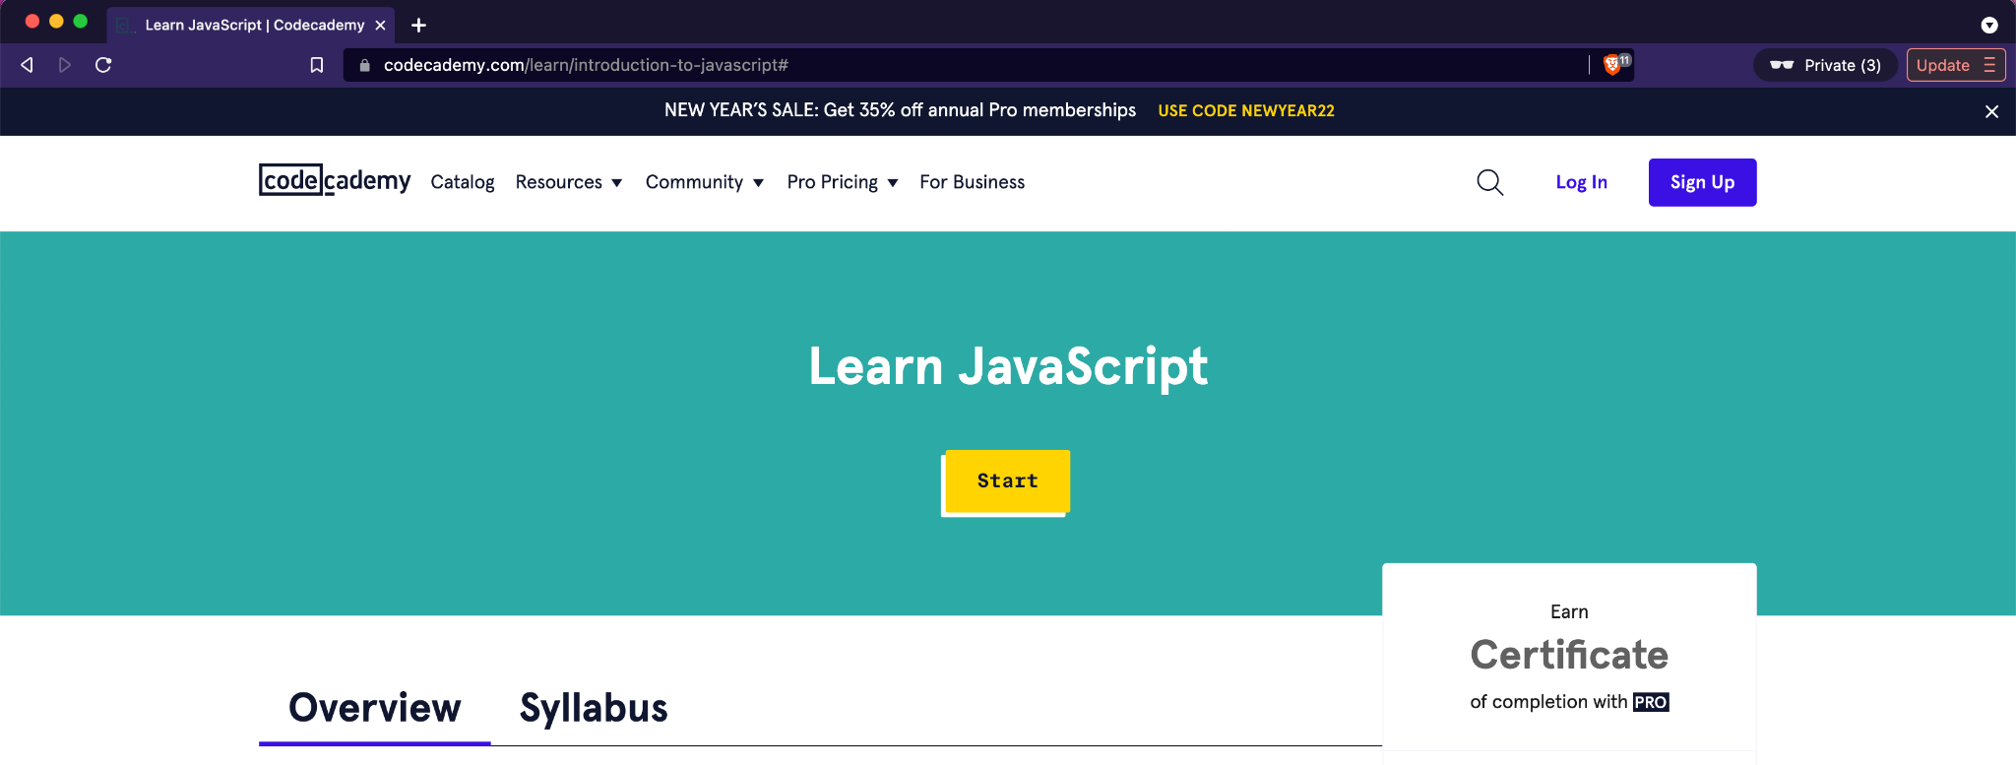

**Step 2**: Login with the id and password that you created if you are not already logged in after Sign Up.

You can see these lessons if you scroll down on that page.

Each of these lesions have a sequence of activities that start from basics.

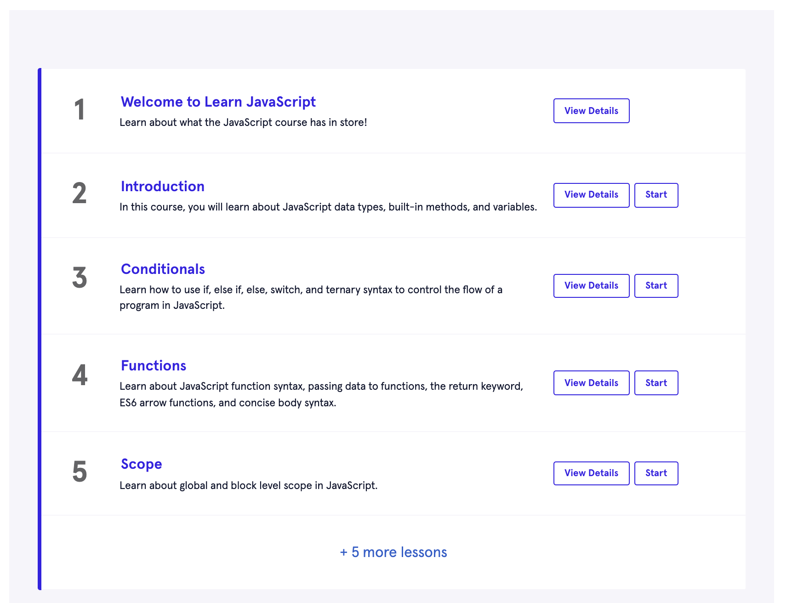

We will be targeting the completion of these 7 lessons marked in Red.

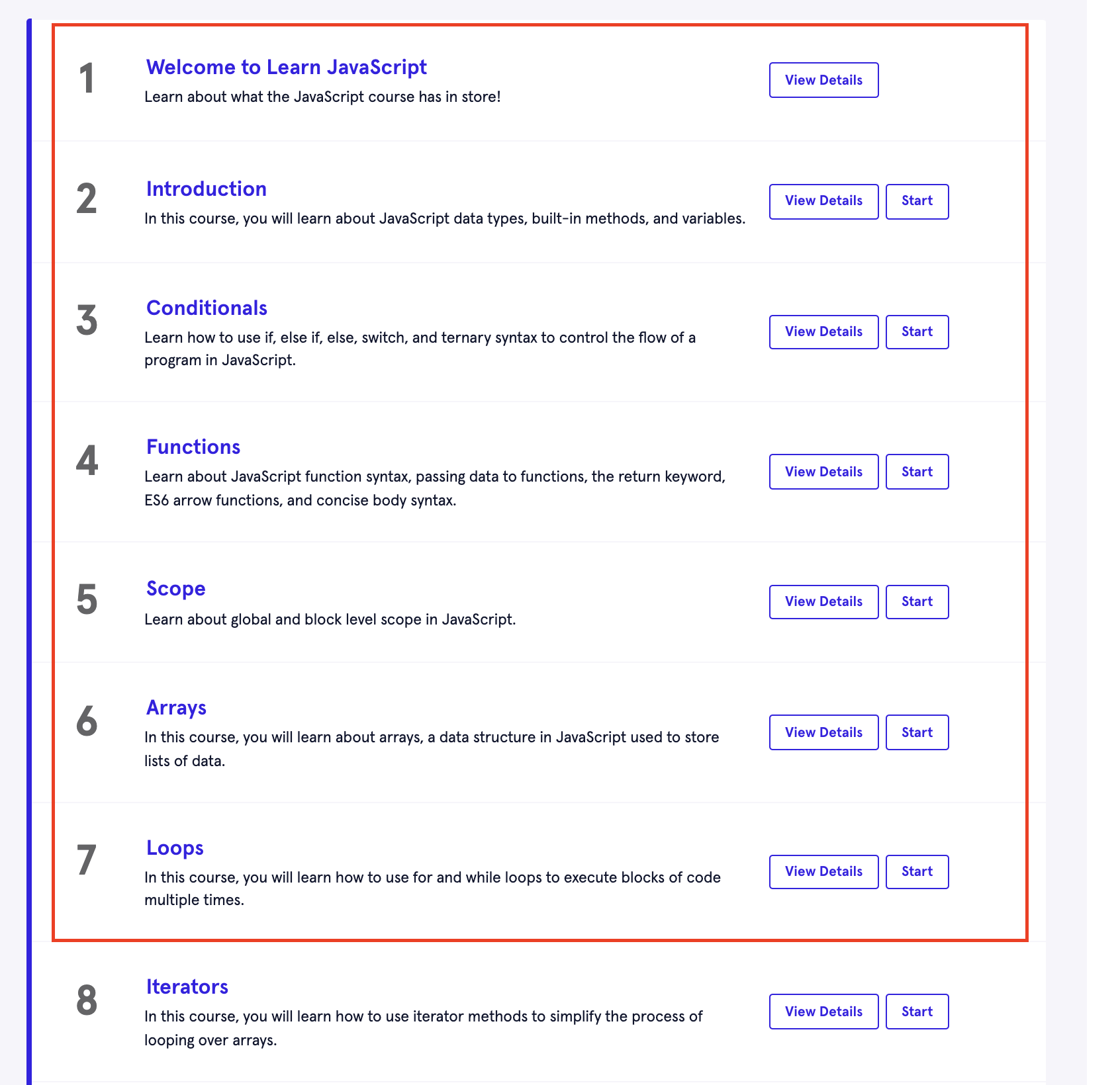

**Step 3**: Click on **Start** at the top to take you to the activities in the first lesson



**Step 4**: You’ll be taken to the Course overview page. Give it a read and click on the **Next** button on the bottom right of the page. You’ll get a prompt to **Start next lesson**. Click on that.

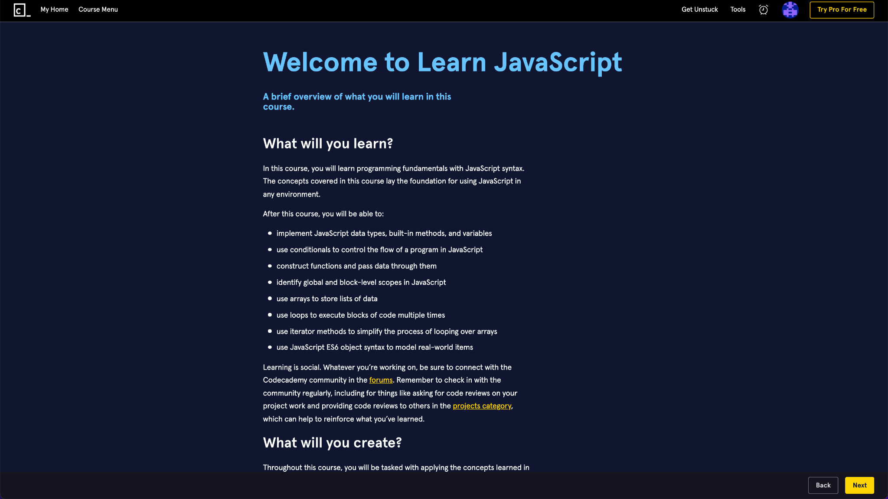

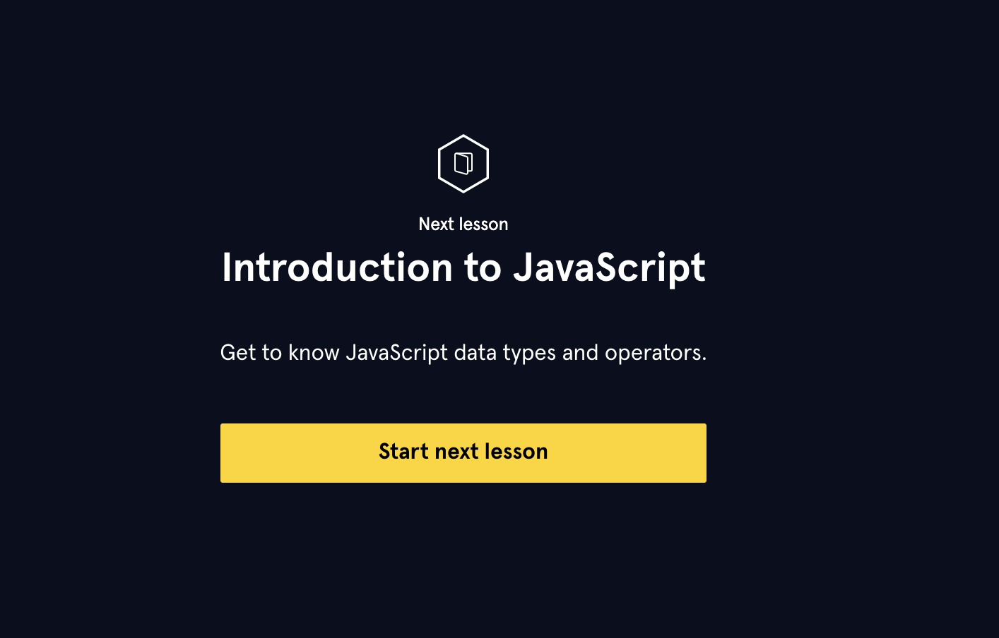

**Step 5**: You’ll come across the below view after you click **Next** for the “What is Javascript?” exercise.

* Read through instructions on the **left**
* Type out make changes to the code in the **middle**
* Hit the **Run** button to see the output on the **right**
* Once you’ve successfully done it, the **Next** button will get enabled to move you to the next activity

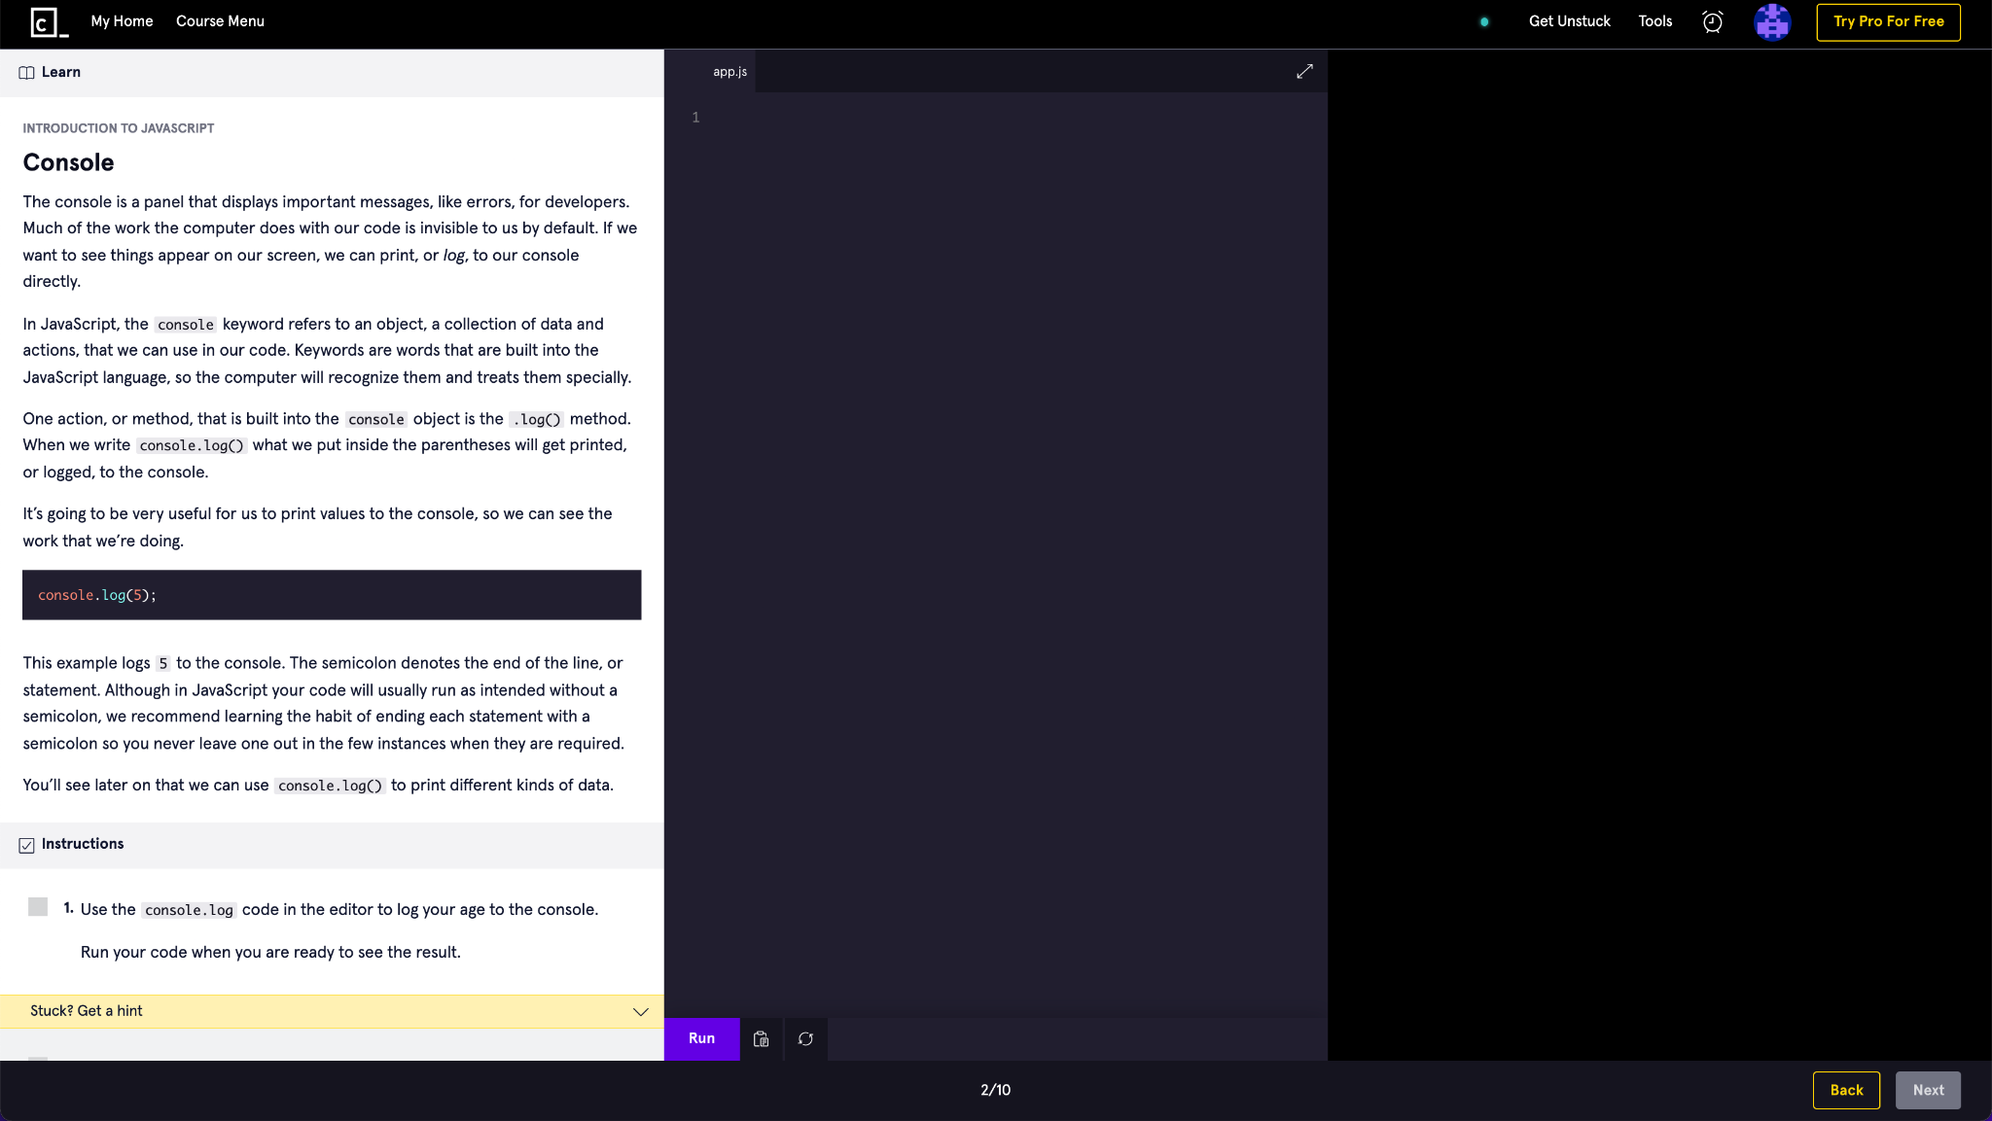

**After you complete all the activities in a lesson, you can move to the next lesson.**

**Please attempt to complete all the 7 lessons as shown in Step 2 (skip the Quiz and Projects in these lessons).**

**Important Notes**

1. There are **hints** and **syntax cheat sheets** available on the left to help you if you’re stuck, make good use of those.
2. **IGNORE the Quiz and Projects** (which are part of the PRO version). The goal is to get introduced to and become comfortable with the basic Java syntax.
3. You **will be** **going through** all of **these concepts again during the track in live sessions** with instructors, but doing these exercises will give you a head start and you can clarify your doubts during those live sessions.

# References

1. [JavaScript Syntax Quick Reference guide](https://quickref.me/javascript)